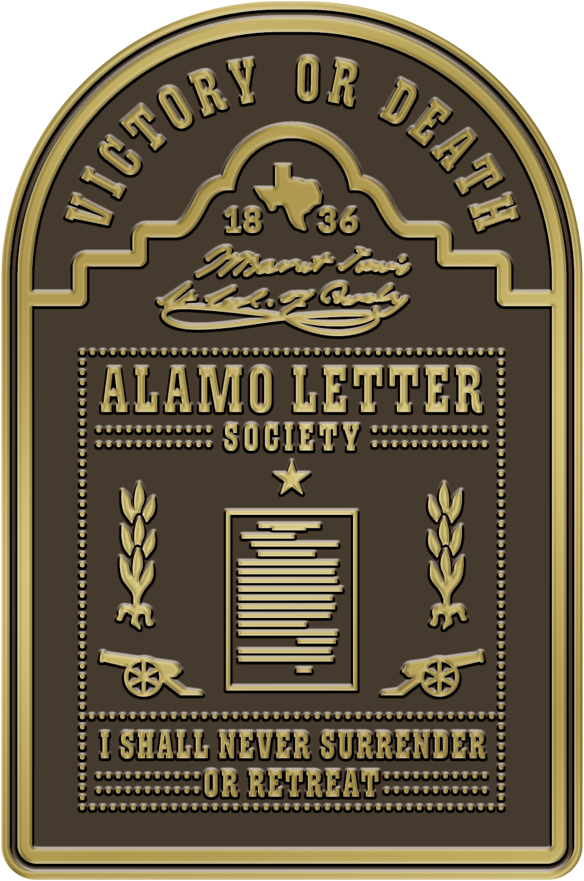**John Vick**

6537 Horizon Road

Suite B, Rockwall

Texas 75032

Public Affairs Officer

Board of Directors

**Alamo Letter Society**

[www.alamoletter.com](http://www.alamoletter.com)

January 26, 2024

**PRESS RELEASE**

**FOR IMMEDIATE RELEASE:**

Contact: Dwayne “Doc” Collins

Phone: (903) 571-0165

Or

John Vick

571 234 2729

[john.vick@senate.texas.gov](mailto:john.vick@senate.texas.gov)

**The Alamo Letter Society Announces**

**Dwayne “Doc” Collins , Canton County Chair**

Dallas, Texas –The Alamo Letter Society is honored to announce Dwayne “Doc” Collins

as their County Chair for Van Zandt County, Texas. A trusted Texas A&M Veterinarian,

Collins has been an active civic leader in the County for over 30 years. He has been a college trustee, volunteer firefighter, and border watcher. Texas Senator Bob Hall nominated “Doc” Collins for this leadership position.

On Veterans Day 2023, the Alamo Letter Society launched with the following Mission Statement: *“To educate current and future Texans about their forefathers' armed struggle for Freedom and Liberty through the placement of a large bronze plaque containing Col. William Barrett Travis's Alamo "Victory or Death" letter, in all 254 Texas Courthouses.”*

2024 marks 188 years since General Antonio Lopez de Santa started marching his army to Texas from Mexico. Three Mexican states, including Texas, were in rebellion. The General soon learned that Texans who value liberty and freedom would defend their family, their land, their property, and their sacred honor, with their lives.

The dedication of the Van Zandt County Alamo Letter Plaque will take place in March at the County Courthouse in Canton, Texas.

The Alamo letter was written on February 24, 1836, and heroically dispatched through the Mexican Army to General Sam Houston by Captain Albert Martin. Only 220 words long, many Texans and other Freedom-loving people around the world hold it in the same high esteem as the U.S. Constitution and the Magna Carta. The Alamo Letter Society is dedicated to the two leading Tejanos of the Texas Revolution, Jose Antonio Navarro and Juan Seguín.

The originator of this idea is 13-year-old Texas school girl, Slone McNutt, who was studying Texas history at the Hockaday School of Dallas. In January of 2023, she visited the Alamo with her family. They were looking at the historic 220-word William Barrett Travis's "Victory or Death" letter on a bronze plaque on the lawn in front of the Alamo chapel. 7th-grade daughter Slone said to her father, Lee William “Bill” McNutt, "Daddy, why aren't these plaques with the famous letter all over Texas? Her question was the reason for the start of this effort. An idea and an organization were born.

McNutt recruited his longtime University Park neighbor and fellow Vanderbilt University graduate, Rosser Newton, Sr., and US Army SGM (Ret) John Vick from Rockwall, who currently serves as the District Director for Texas Senator Bob Hall, to aid in the birth of the organization.

Sylvia Navarro Tillotson, the direct descendent of Jose Antonio Navarro said, “José Navarro, a signer of the Texas Declaration of Independence helped create the 1836 and 1845 Constitutions of Texas. He was a Texas patriot passionate about independence, opportunity, and the rights of all Texans.”

“Travis Alamo letter shows us today the essential qualities of being Texan: duty, honor and self-sacrifice. Travis’ sacrifice at the Alamo is the bedrock of Texas values.” said Founding board member Rosser Newton who is working hand in glove with Dwayne Collins. Mr. Newton is a investment banker in the energy sector. He has purchased, grown and sold several oil and gas service companies.

The Alamo Letter Society is recruiting a single Chairperson in each County to serve as a third co-chair with Rosser Newton and Bill McNutt. Each County Chair will work with the local County Judge and County Commissioners to secure a site for the plaque either inside the Courthouse or on the Courthouse grounds. Each County Chair will organize, plan, and accomplish a historic dedication ceremony involving local schools, bands, military bases, the Daughters and Sons of the Republic of Texas, and more. Self-nominations for County Chairs are welcome. Please call [214-537-9311](tel:1+214-537-9311) for more information.

The following Counties have already announced their dedication dates:

- Ellis County Dedication, Friday Feb 23, 2024, 3pm, Courthouse in Waxahachie.

- Rockwall County Dedication will be on the 188th anniversary of the writing of the letter, Feb. 24, 2024, 10am at the New Courthouse.

- Van Zandt County Dedication, late March 2024, at the Courthouse in Canton.

- Nueces County, last week in March 2024 at the Courthouse in Corpus Christi

- Hood County Dedication, San Jacinto weekend, April 20-21, 2024.

"The spirit of the Alamo letter has been carried by all subsequent generations of Texas fighting men to every battlefield from Gettysburg, to Omaha Beach, from the Battle of the Somme to Iwo Jima. The Texas solider always finds a way forward.“ John Vick, President, Alamo Letter Society 501 C 3.

**ALAMO LETTER SOCIETY**

The Alamo Letter Society exists to educate school children, new Texans and future generations, of their forefathers' fight for Liberty, and Freedom, through the placement of a large 110 pound bronze plaque containing the Alamo letter at each of the 254 courthouses in the Lone Star State. [www.alamoletter.com](http://www.alamoletter.com)

###